DAY 23
Task 1:
1. What distinguishes a Brownfield application from a Greenfield one in terms of constraints and opportunities?
- Brownfield applications are existing systems with legacy code, dependencies, business rules, and operational constraints. They must preserve current functionality while being modernized.
- Greenfield applications are built from scratch with no legacy constraints, allowing teams to choose modern architectures, technologies, and design patterns freely.
- Brownfield offers opportunities to leverage proven business processes, while Greenfield offers maximum innovation and flexibility.
3. How do business drivers such as cost reduction, agility, and compliance influence migration decisions?
Business drivers determine the justification and priorities for migration:
- Cost reduction encourages moving away from expensive legacy infrastructure and support models.
- Agility drives adoption of cloud-native platforms that enable faster releases and scalability.
- Compliance may require modernization to meet evolving regulatory and security requirements. These drivers help select the most appropriate migration strategy and investment level.
5. What is the purpose of conducting an application portfolio assessment before migration?
- An application portfolio assessment provides a complete understanding of applications, their business value, technical health, dependencies, costs, and risks. It helps organizations decide which applications should be retired, retained, rehosted, refactored, or rebuilt and creates a data-driven modernization roadmap.
7. Why is mapping integration points critical when planning migration?
- Integration points connect applications, databases, APIs, messaging systems, and external services. Mapping them ensures these connections continue working after migration, preventing outages, data inconsistencies, and business process disruptions.

9. How does technical debt impact modernization strategy selection?
High technical debt often makes simple lift-and-shift migrations less effective because underlying issues remain unresolved. Applications with significant technical debt may require refactoring, rearchitecting, or rebuilding to reduce long-term maintenance costs and improve reliability.
11. What are the main risks in database migration, and how can they be mitigated?
Risks:
- Data loss or corruption
- Downtime during migration
- Performance degradation
- Incompatible schemas or database features
Mitigation:
- Thorough testing
- Data validation and reconciliation
- Backup and rollback plans
- Phased migration approaches
- Performance benchmarking before and after migration
13. Why must security and compliance be reassessed during migration, even if the application was previously compliant?
- Migration changes the application's environment, architecture, data flows, and security controls. New cloud services, regulations, and threat landscapes may introduce risks that previous compliance assessments did not address. Reassessment ensures continued compliance and protection.
15. How do the 6 R’s of migration provide a framework for decision-making?
- The 6 R's (Retire, Retain, Rehost, Replat form, Refactor, Rebuild/Replace) provide a structured method for evaluating each application based on business value, technical condition, cost, and risk. This framework helps organizations choose the most suitable migration path rather than applying one approach to all applications.
17. How does TCO (Total Cost of Ownership) differ from upfront migration cost?
- Upfront migration cost includes immediate expenses such as assessment, migration tools, implementation, and training.
- TCO includes all long-term costs throughout the application's lifecycle, such as infrastructure, licensing, operations, maintenance, security, support, and future upgrades. TCO provides a more complete view of financial impact.
19. What factors determine wave planning for application migration?
Wave planning is determined by:
- Business criticality
- Application complexity
- Dependency relationships
- Migration risk
- Resource availability
- Technical readiness
- Expected business benefits
Applications with lower risk and fewer dependencies are often migrated first.
21. How does defining a target-state architecture guide modernization choice?
Target-state architecture defines the desired future environment, including technology stacks, integration patterns, security standards, and deployment models. It serves as a blueprint that guides migration decisions and ensures modernization efforts align with long-term business and technology goals.
23. What are the key indicators that an application is cloud-ready?
Common indicators include:
- Loosely coupled architecture
- Stateless application design
- API-driven communication
- Automated deployment pipelines
- Scalability requirements
- Minimal dependence on physical hardware
- Externalized configuration and storage
- Support for containerized deployment

25. Why are KPIs critical in measuring migration success?
- KPIs provide measurable evidence that migration objectives have been achieved. They allow organizations to track improvements in performance, availability, cost savings, security, deployment speed, and user satisfaction while demonstrating business value.
27. What role do assessment tools play in reducing subjectivity during migration planning?
- Assessment tools collect and analyse application, infrastructure, dependency, performance, and cost data objectively. This data-driven approach reduces personal bias, improves consistency, and enables informed migration decisions based on measurable facts rather than assumptions.
-------------------------------------------------REDIS-----------------------------------------------------
Task 1:
Redis (Remote Dictionary Server) is an in-memory data store used to store and retrieve data extremely quickly.
- Extremely fast (RAM-based)
- Reduces database workload
- Improves scalability
- Supports real-time applications
- Easy integration with cloud and microservices architectures
Task 2:
Redis architecture is built around a highly efficient single-threaded core engine that uses non-blocking I/O multiplexing to process hundreds of thousands of operations per second with sub-millisecond latency.
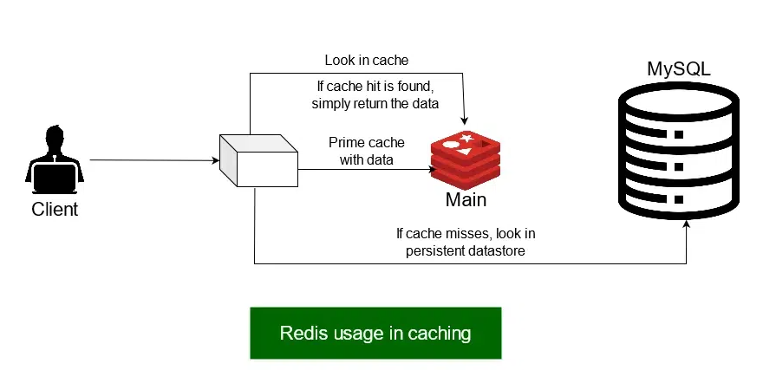
Task 3:
Advantages of Redis
- Blazing Fast Speed: Stores data in RAM (Random Access Memory) instead of a hard drive, allowing reads and writes in microseconds.
- Rich Data Structures: Goes beyond basic key-value strings to support lists, hashes, sets, sorted sets, and streams.
- High Availability & Scaling: Offers built-in replication, automatic sharding, and Redis Sentinel for failover support.
- Optional Persistence: Can save data to disk using snapshotting (RDB) or append-only files (AOF) if needed.
- Versatile Use Cases: Great for caching, session management, real-time leaderboards, and pub/sub messaging.
Disadvantages of Redis
- Memory Limitations: All data must fit inside RAM, making it very expensive for massive, terabyte-scale datasets.
- No SQL Query Language: Lacks support for complex joins, multi-table lookups, or ad-hoc searching.
- Risk of Data Loss: If used purely in-memory without strict persistence configurations, a sudden power loss or server crash can wipe recent changes.
- Single-Threaded Bottleneck: Core command execution is single-threaded, meaning heavy, long-running operations can block other incoming requests.
Task 4-16: Demo work
Task 17:
Cache-Aside improves performance by loading data into the cache only when needed. However, when database updates occur frequently, stale data can remain in the cache until invalidated or refreshed, creating consistency challenges.
Task 18:
Write-Behind introduces consistency challenges in critical transactional workloads where every update must be immediately persisted. In such systems, Write-Through is preferred because it ensures the database and cache remain synchronized.

Task 19:
LFU is often preferred in recommendation systems because it retains the most frequently accessed content rather than simply the most recently used content. This helps keep popular recommendations available in cache for longer periods.
Task 20:
Time-Based | Event-Based
Simple | More Complex
Can Serve Stale Data | Near Real-Time Updates
TTL Driven | Change Driven
Lower Cost | Higher Complexity

Task 21:
In a real-time stock trading system, event-based cache invalidation should be used because stock prices change continuously. Whenever a market update occurs, the cache should be updated or invalidated immediately to ensure traders receive the most current information.
---------------------------HOME TASK--------------------------------------------------------------------
Task 22:
Redis sharding improves scalability by distributing data and requests across multiple nodes, increasing memory capacity, throughput, and overall performance. However, it adds complexity because related keys may be stored on different shards, making multi-key operations, transactions, and data management more challenging. Proper key design, such as using hash tags, helps reduce these challenges.

